Day 15 - 104608492 - Shirisha Perapagu

Trees and Graphs

Task1 to Task4 ( all in one class named Task1to4)

1. TreeNode Creation

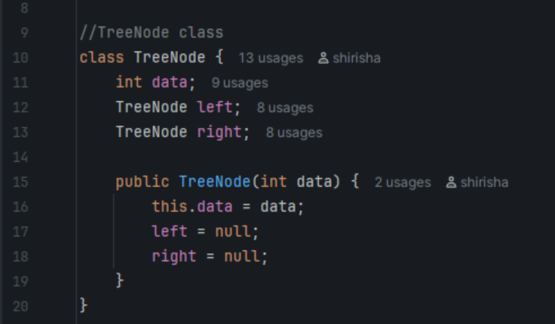

1. Insertion

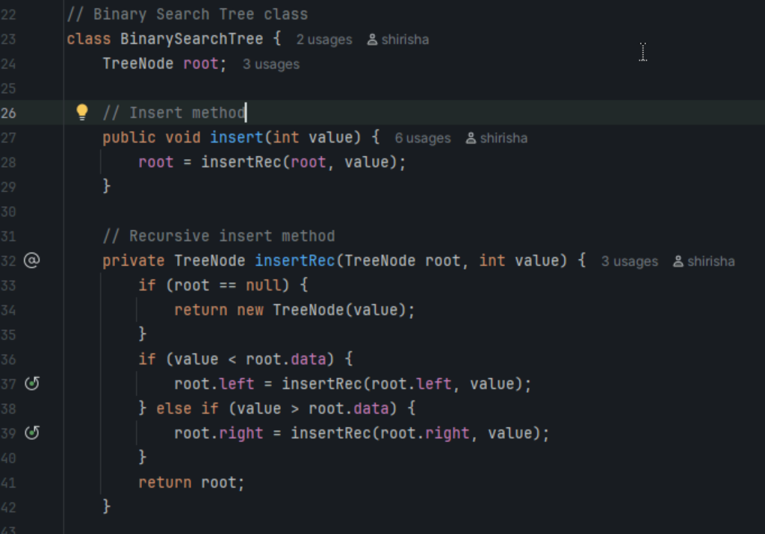

1. Inorder traversal

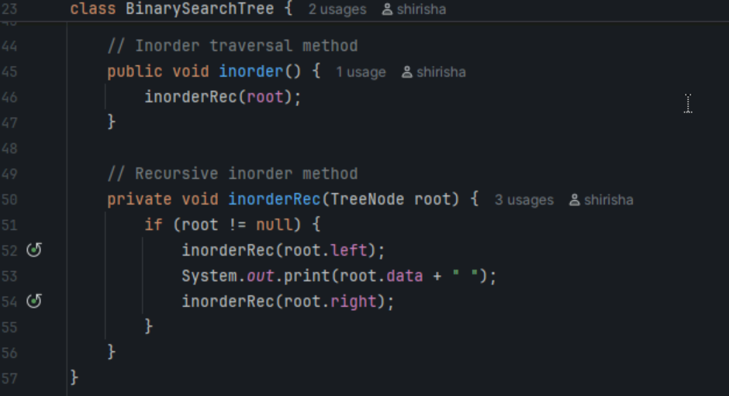

1. Main method

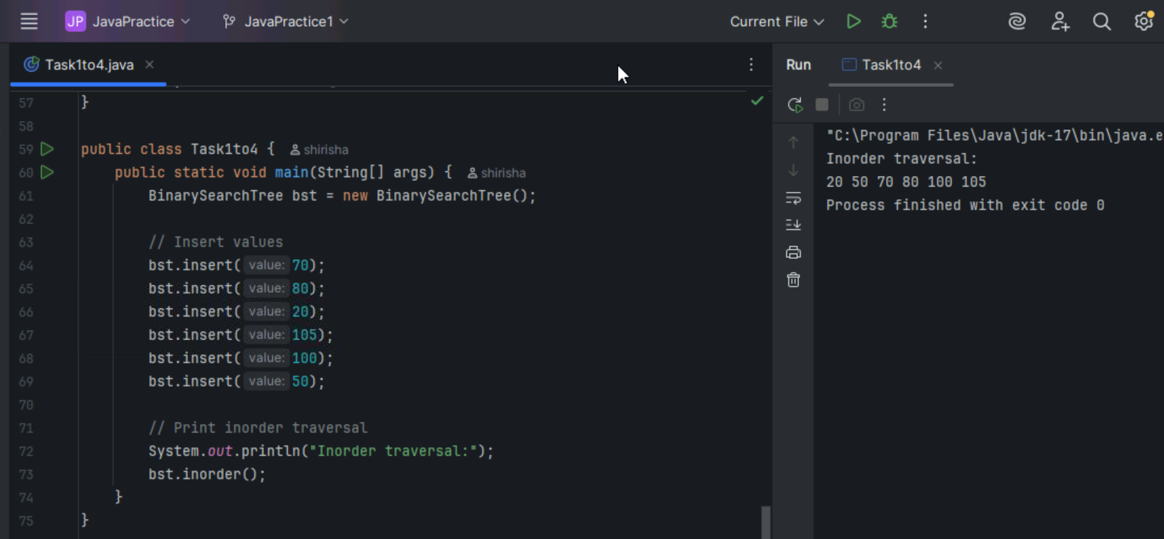

Task 5

Applications of Trees

1. File systems – use trees to manage folders and file hierarchically.
2. Databases – B-Trees used for fast searching and indexing.
3. Compilers – use syntax trees to analyze and parse code.
4. AI in games – uses decision trees to choose best actions.
5. Autocomplete systems use Trie trees for quick word suggestions.

Task 6

Searching operation in BST

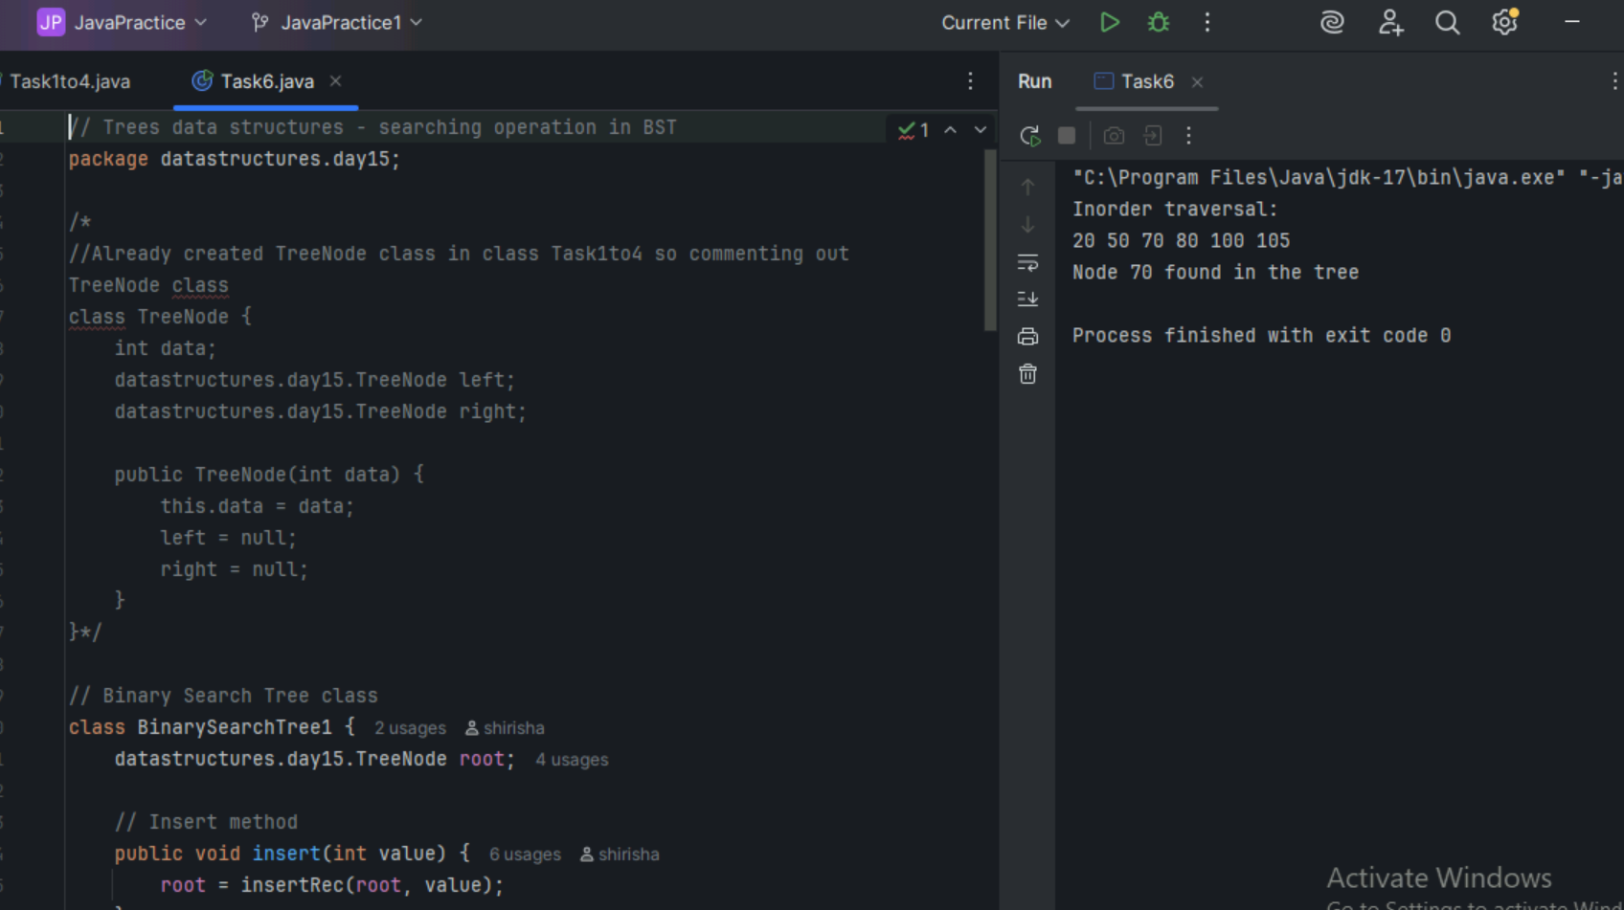

Task 7

Types of Binary Trees

1. Rooted Binary Tree
2. Full/Strictly Binary Tree
3. Complete/Perfect Binary Tree
4. Almost Complete Binary Tree
5. Skewed Binary Tree

Task 8

Applications of Graph

1. Google Maps and GPS – to find shortest routes between locations.
2. Search Engines – ranking web pages based on their connections and popularity.
3. Social networks use graphs to represent connection between friends/followers etc.
4. Airline networks – to show flight paths between cities.
5. Recommendation systems like apps Netflix or Amazon uses graph to suggest items based on user preferences.

Task 9

Types of Graphs

1. Directed Graph
2. Undirected Graph
3. Weighted Graph
4. Unweighted Graph
5. Connected Graph
6. Disconnected Graph
7. Cyclic Graph
8. Acyclic Graph
9. Regular Graph
10. Complete Graph

Task 10

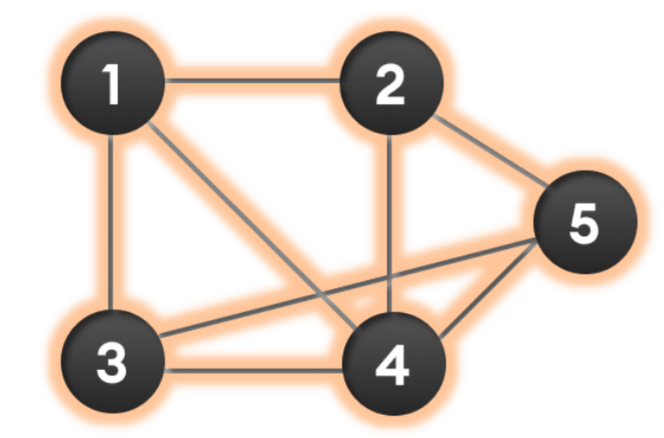

Wap to display graph edges in the below order no. of edges 8 and no of vertex 5.

1 - 2

1 - 3

1 - 4

2 - 4

2 - 5

3 - 4

3 - 5

4 – 5

